**Marwadi Foods**

A food ordering website made using Java, JDBC, JSP and servlets.

I made this project in my 5th semester for my Advanced Java Programming. We were supposed to use JSP and Servlets for the same.

The website was on local host using Tomcat server. JDBC and MYSQL were used to create a database for the application.

I will now walk you through the different webpages and features of the website.

* **Login Page**

This is a simple html page which has a form and uses 'post' method to pass on the form values to ***loginCheck.java*** for validating login.

One can also register a new account if they don't have an existing account.

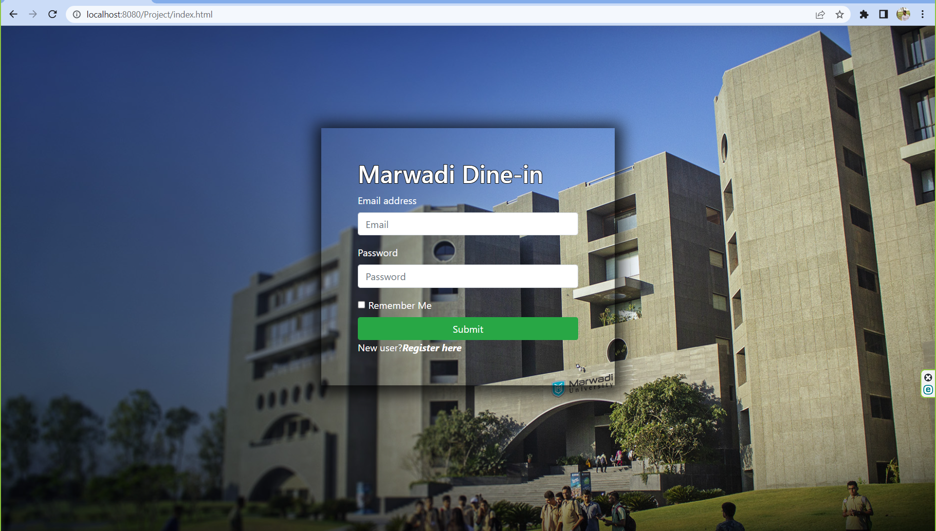

* **Register Page**

This page is again using a form to get information from the user using 'post' method to pass on the form values to ***registerInput.java*** for registering the new user and making a corresponding entry in the database. Certain constraints were put on values being entered for the email and password to verify they're in the correct format and adequate length.

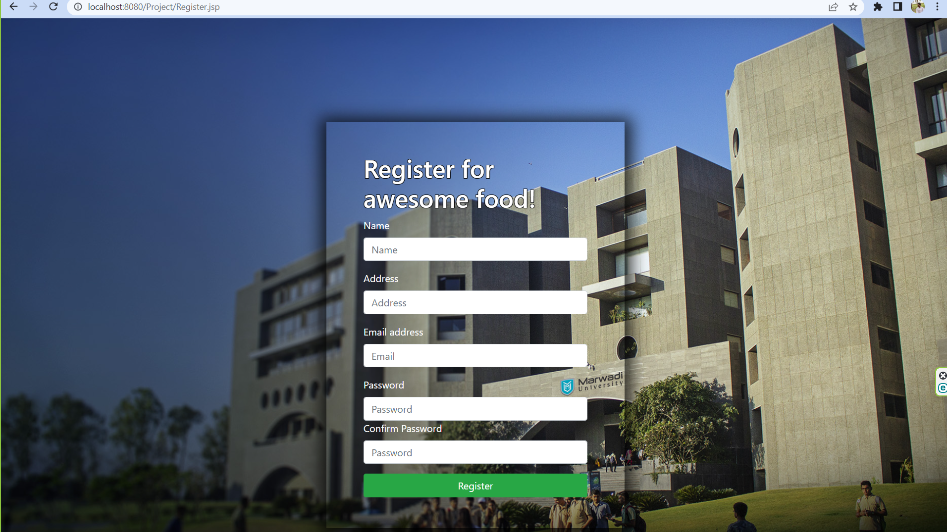

After entering the required information and clicking on the Register button the user is redirected back to the login page where they can login using their registered email id and password.

* **Welcome Page**

Once the user has successfully logged in they will be taken to the menu page i.e. Welcome.jsp and the users session will start. This page has a navigation bar with a logout button and a button to go to the cart.Further it has multiple containers with the images of various food items with buttons to add them to cart. If a user clicks on logout their session ends and they're redirected to the login page.If a user clicks on the Add to Cart button a value is passed to addToCart.jsp this program adds the item to cart while the user is still on the menu page. A user can add multiple items to their cart.

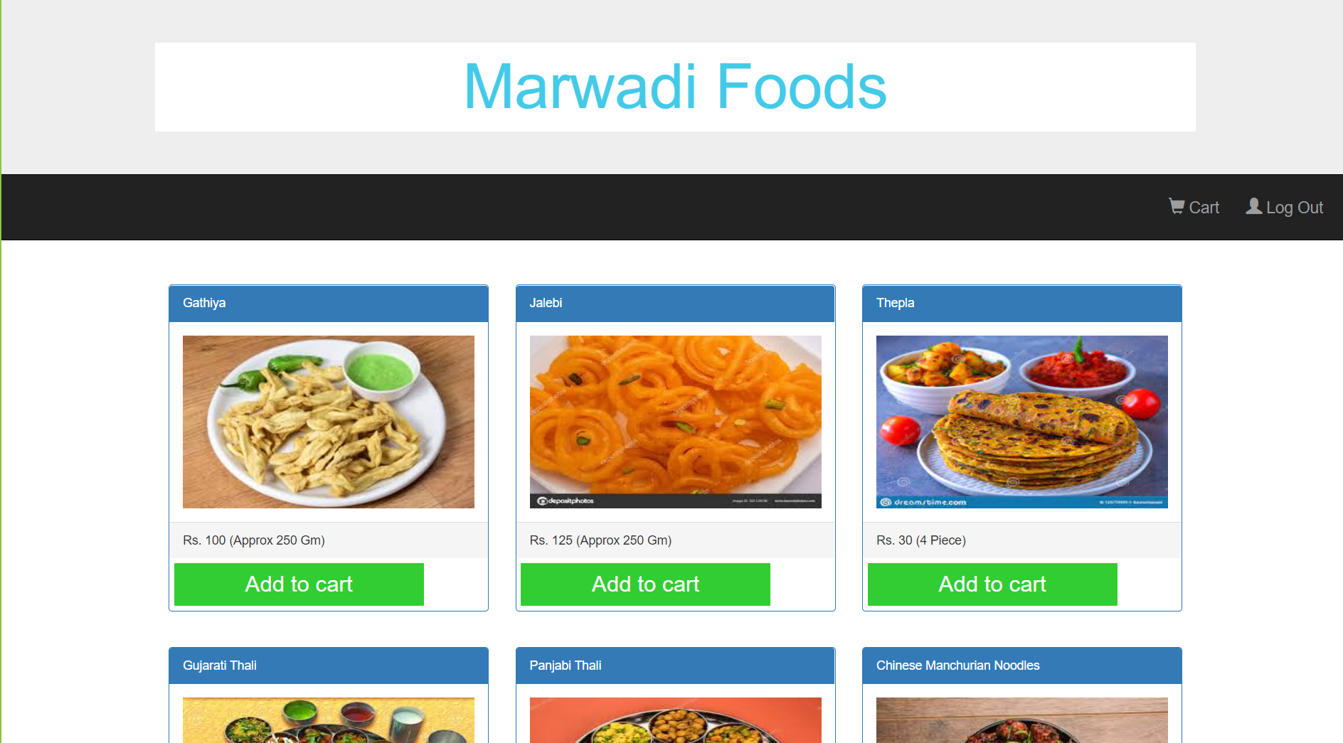

* **Cart Page**

When the user clicks on Cart button on the navigation bar they're taken to cart.jsp where the added items are shown to the user.

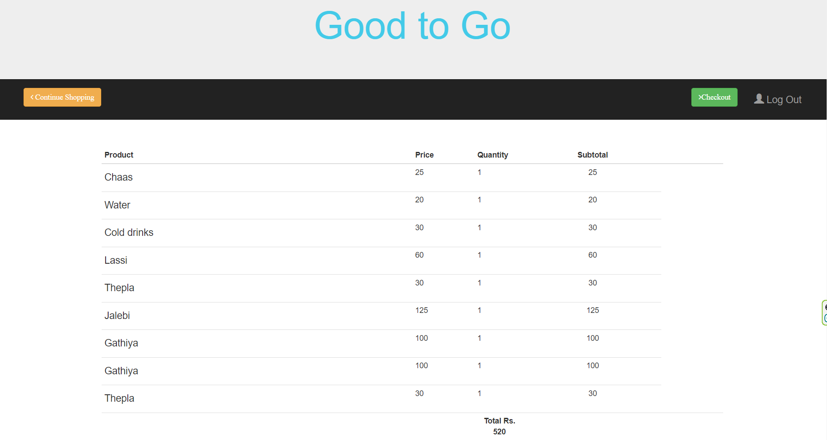

From this page the user can either go back to the menu page to add more items by clicking on Continue Shopping button or click on Checkout Button.

* **Checkout Page**

On clicking the checkout button the user is taken to Checkout.jsp page. On This page the user has 2 options that is to logout or to move back to menu page if wants to reorder.

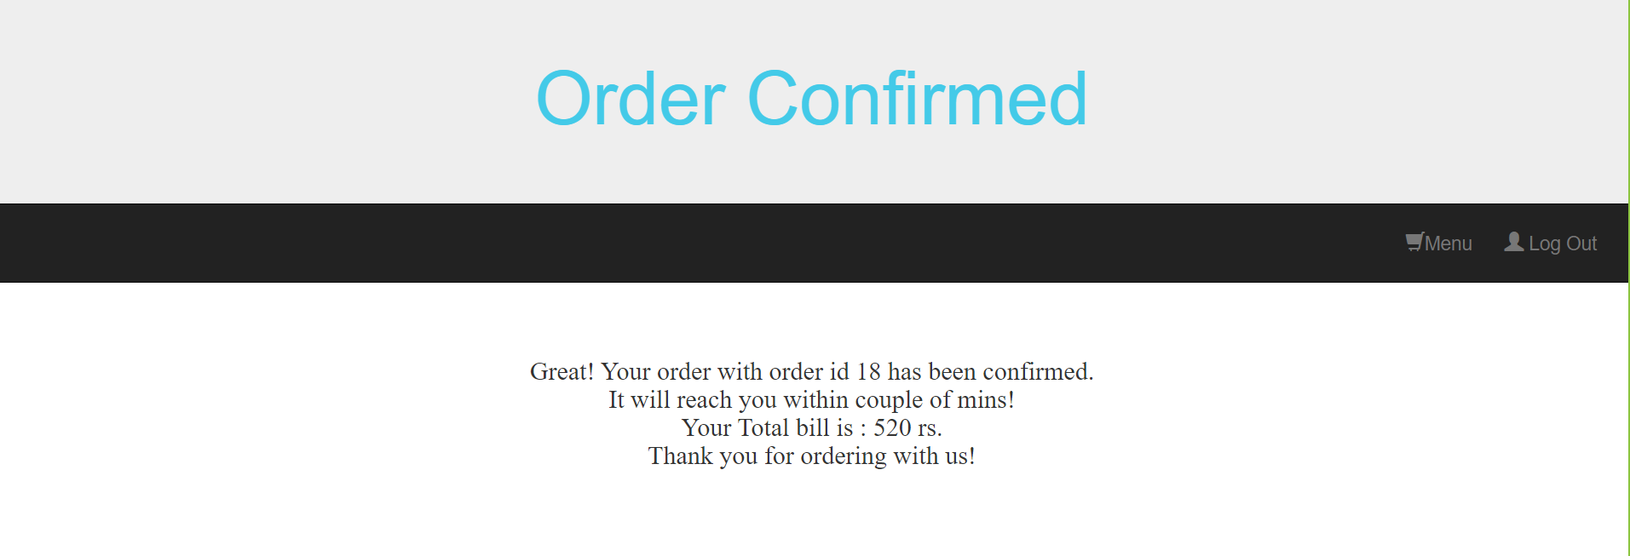

Now, coming to the database part of the application. I have used MYSQL to create my database and tables. It was connected to my code using JDBC.

The following are the tables which were created in the db.

* **customer table**

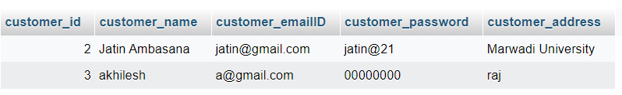

* **drinks table**

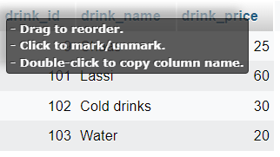

* **food table**

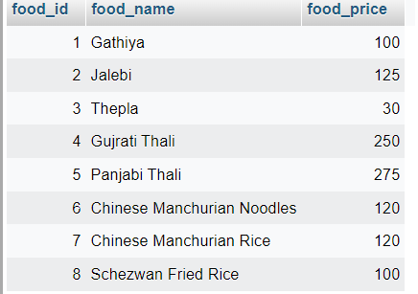

* **drinkOrder table**

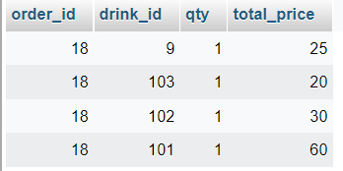

* **foodOrder table**

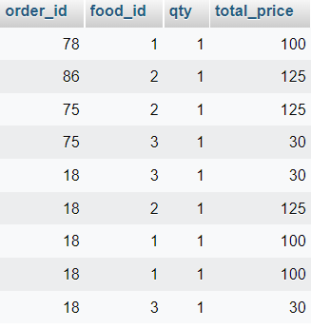

* **totalOrder table**

